Chapter 6, Problem 56.

Find L_{eq} in the circuit in Fig. 6.78.

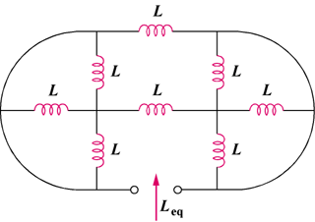

Figure 6.78
For Prob. 6.56.

